SSL Certificate Renew & Installation - Step by Step
Updated date 8-April-2025
SSL team contact email kimsiang.kang@seagate.com and it-app-ssl-support@seagate.com
1) Create CSR file by below documents and save to your local.
Notes CSR – For Windows:
make sure to add 4 hostnames in DNS Page 8, Step 13
sfsweb.woo.sing.seagate.com => *** must add for big IP routing
woodsfswd.woo.sing.seagate.com
woodsfsw1.woo.sing.seagate.com
woodsfsw2.woo.sing.seagate.com
Create CSR – Windows.pdf
Create CSR – Linux.pdf
2) Raise the ticket (One request per IIS server) to Global SSL Admin team in freshservice (Choose Report an issue) and attached csr file from step 1 in the ticket.
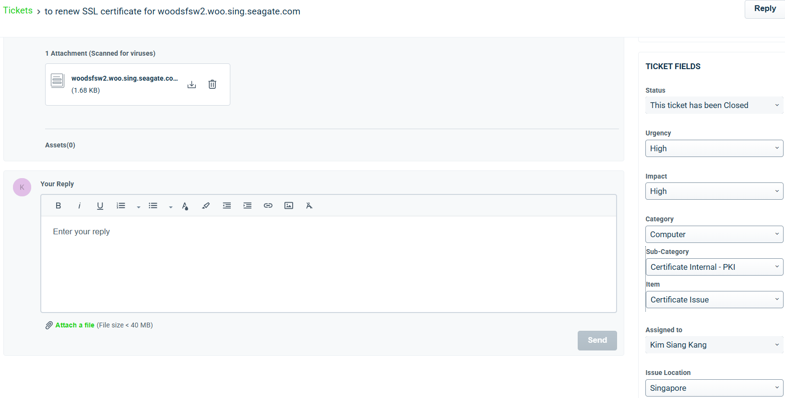
3) Inform Kim Siang or SSL Admin about the tickets. They will send back the new SSL Certificate cer file via email for each request.
4) Install cer file in the IIS server by below document
- start from page 9, step 15 till the last step in the document. Ignore the page 1 to 8 which is obsolete
How to Request and Install Certificate on IIS Server.pdf

